| **Ex No: 6.4**  **Date: 11-09-24** | **Autoencoder Model on Fashion MNIST Dataset** |
| --- | --- |

**Objective:** To build and train a convolutional autoencoder that denoises Fashion MNIST images, and display its performance in reconstructing images from noisy inputs.

**Descriptions:**

Dataset:

* The Fashion MNIST dataset is used for training and testing. It contains 60,000 training and 10,000 test images of clothing items, with 10 classes. Each image is of size 28x28 pixels and is grayscale.

Noise Addition:

* A function map_image_with_noise() is used to normalize the images and add Gaussian noise to each image with a noise factor of 0.5.

Model Architecture:

* The model is a convolutional autoencoder that consists of three parts: Encoder, Bottleneck, and Decoder.
* Encoder: Uses two convolutional layers with filters 64 and 128, followed by max-pooling layers to reduce the spatial dimensions.
* Bottleneck: A convolutional layer with 256 filters that compresses the features, followed by another convolutional layer for generating the encoder visualization output.
* Decoder: Upsamples the compressed features back to the original image size using two convolutional and upsampling layers.
* The final output is the reconstructed image.

Training:

* The model is trained using the Adam optimizer and binary cross-entropy loss for 40 epochs with a batch size of 128.
* Training and validation loss are monitored to track model performance.

Evaluation:

* Sample results are displayed by feeding noisy test images through the encoder and decoder to visualize how well the model reconstructs the clean images.

**Model:**

https://piehqfpkotypaenhpraenx.coursera-apps.org/notebooks/Week%202/Logistic%20Regression%20as%20a%20Neural%20Network/images/LogReg_kiank.pnghttps://piehqfpkotypaenhpraenx.coursera-apps.org/notebooks/Week%202/Logistic%20Regression%20as%20a%20Neural%20Network/images/LogReg_kiank.png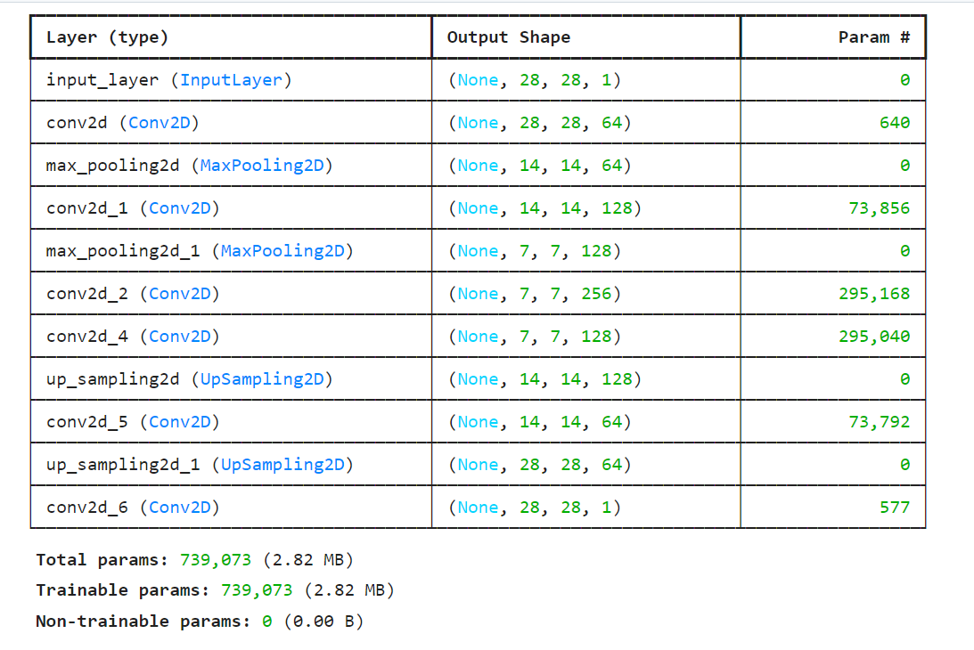

#### Training and Results:

* The model was trained for 40 epochs, achieving a final training loss of 0.2774 and validation loss of 0.2804.
* Sample outputs were displayed using noisy input images, the encoded representation, and the reconstructed images.

**GitHub Link:**[**https://github.com/Yashr22/Lab-6.4-Denoising.git**](https://github.com/Yashr22/Lab-6.4-Denoising.git)